Three Ways to return the data from controller action method in ASP.NET CORE Web API

1. Specific Type

2. IActionResult

3. ActionResult of T

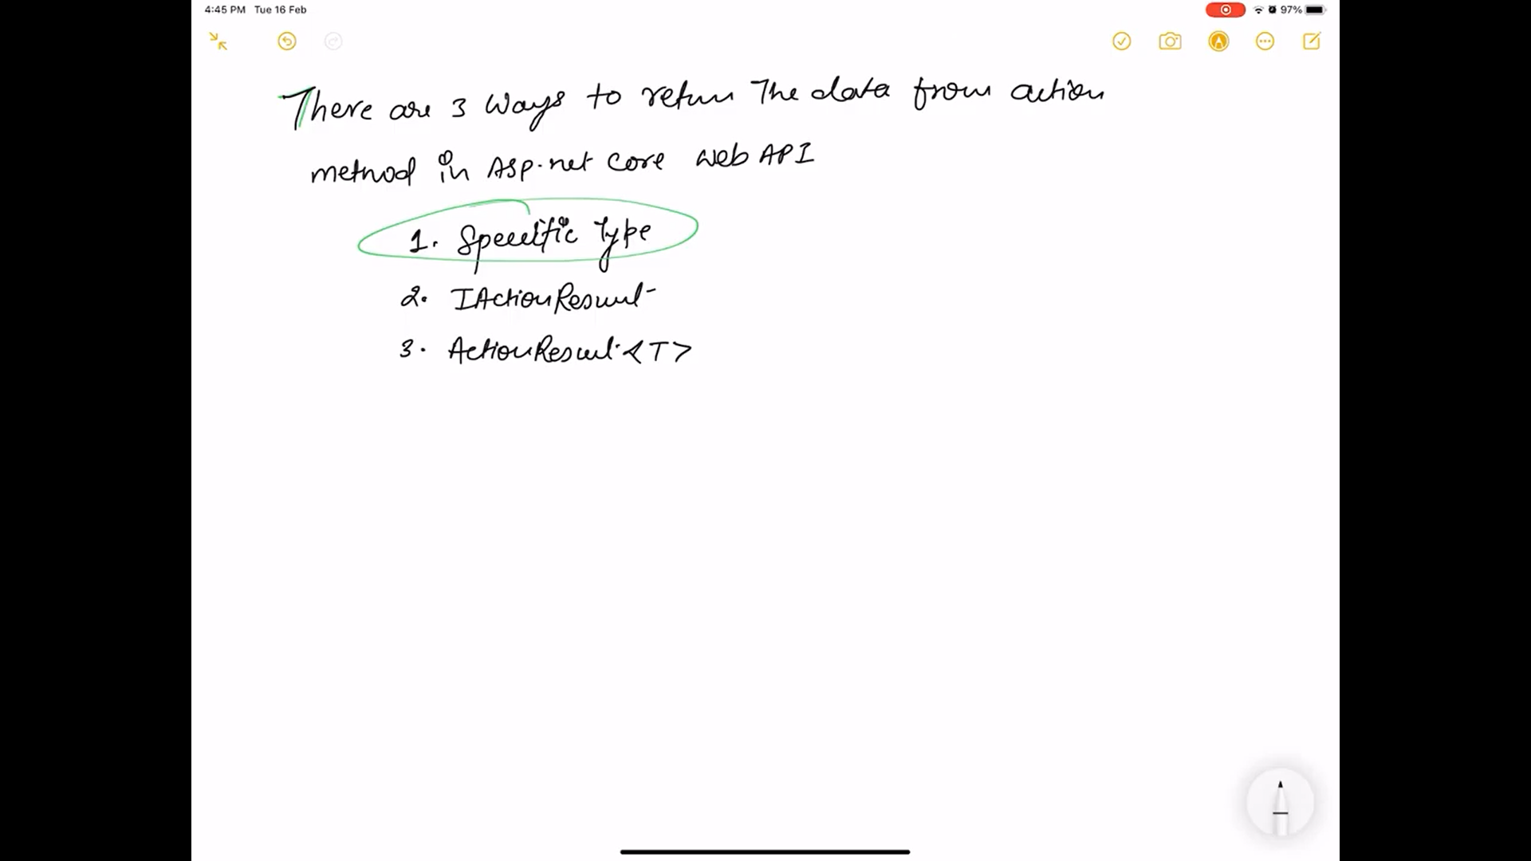

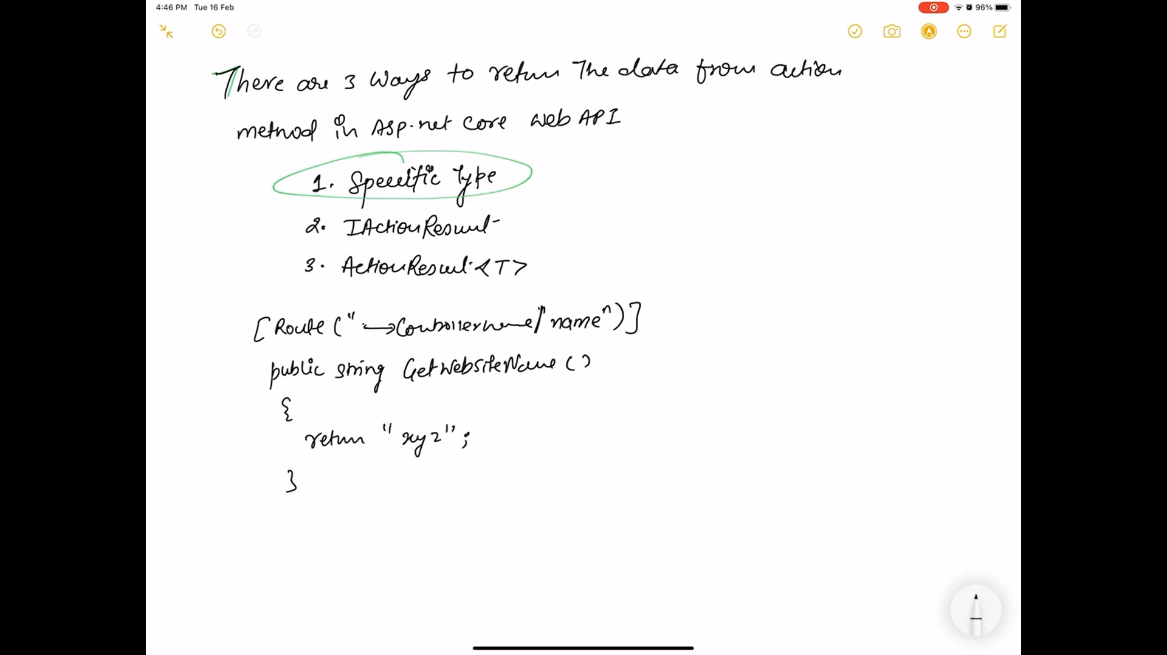

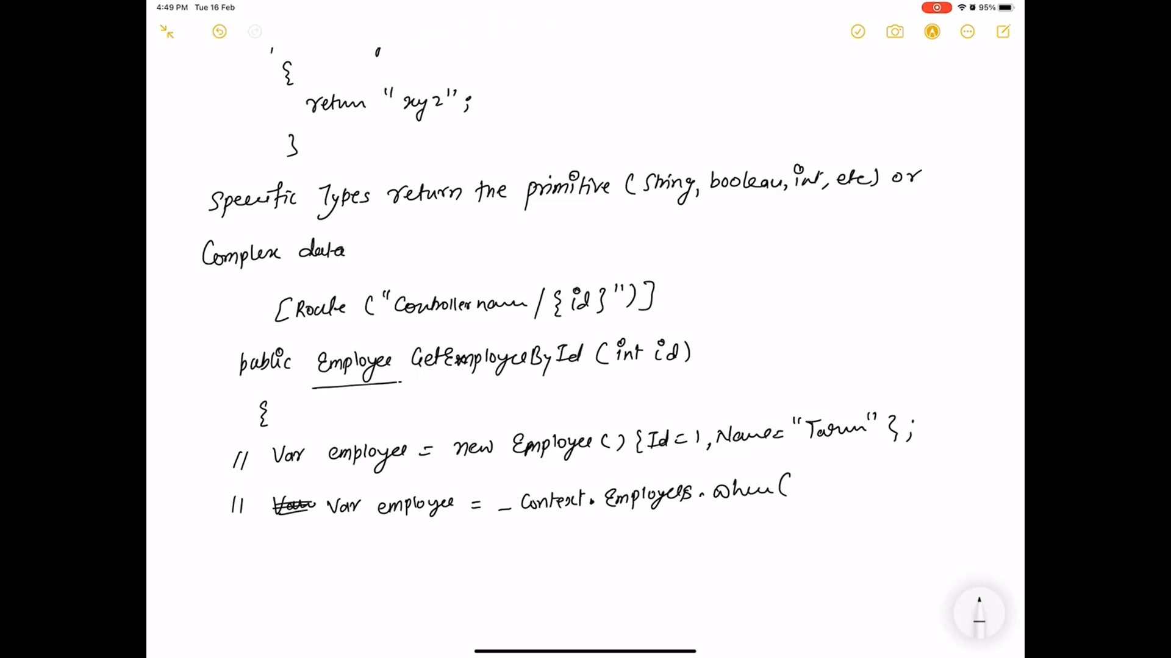 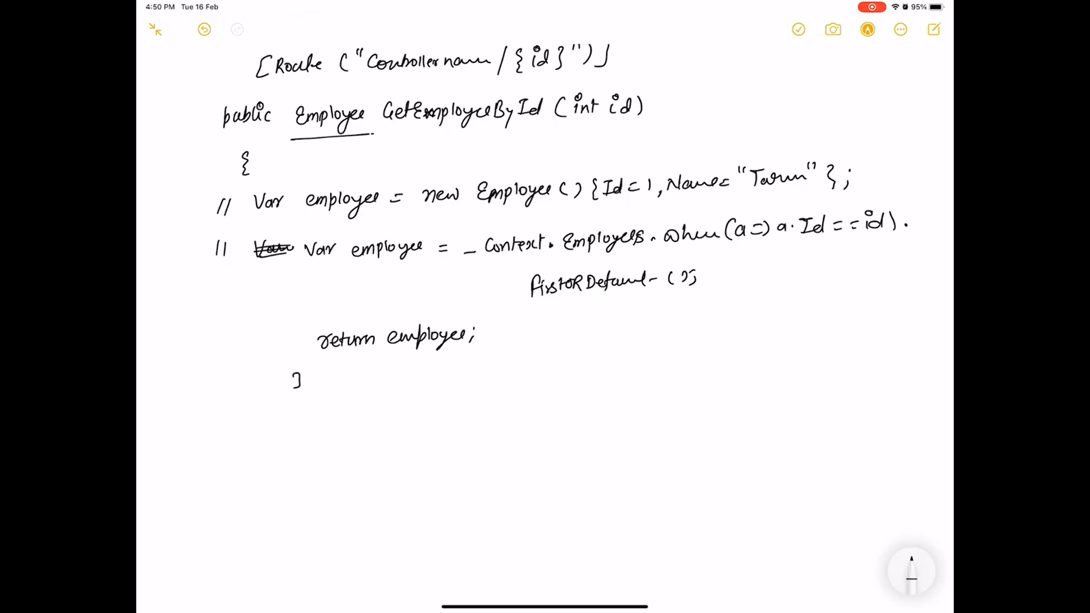

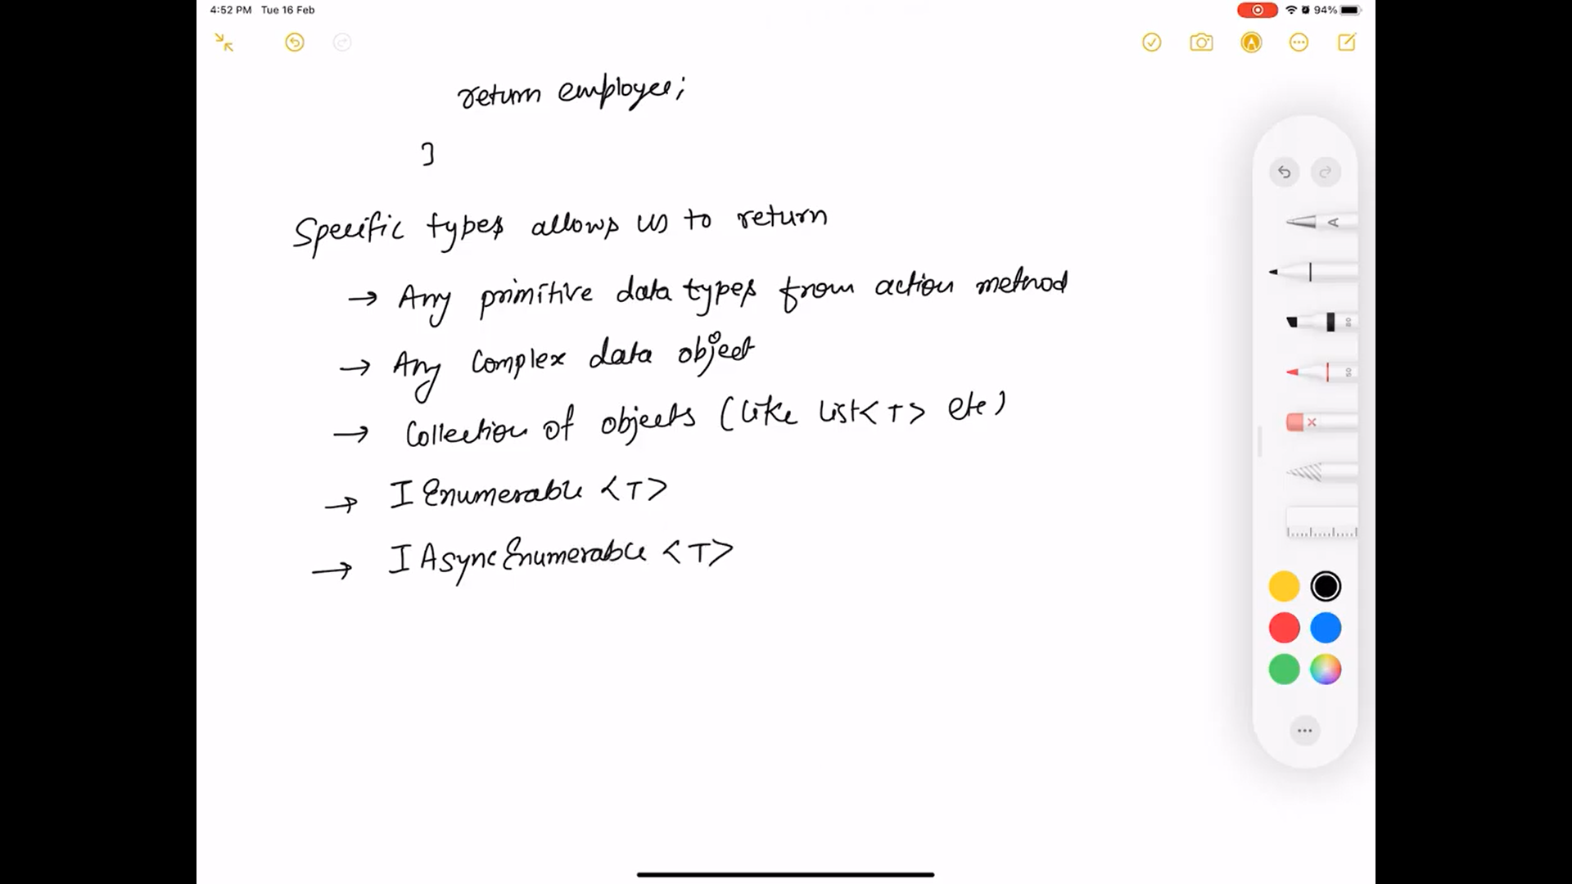

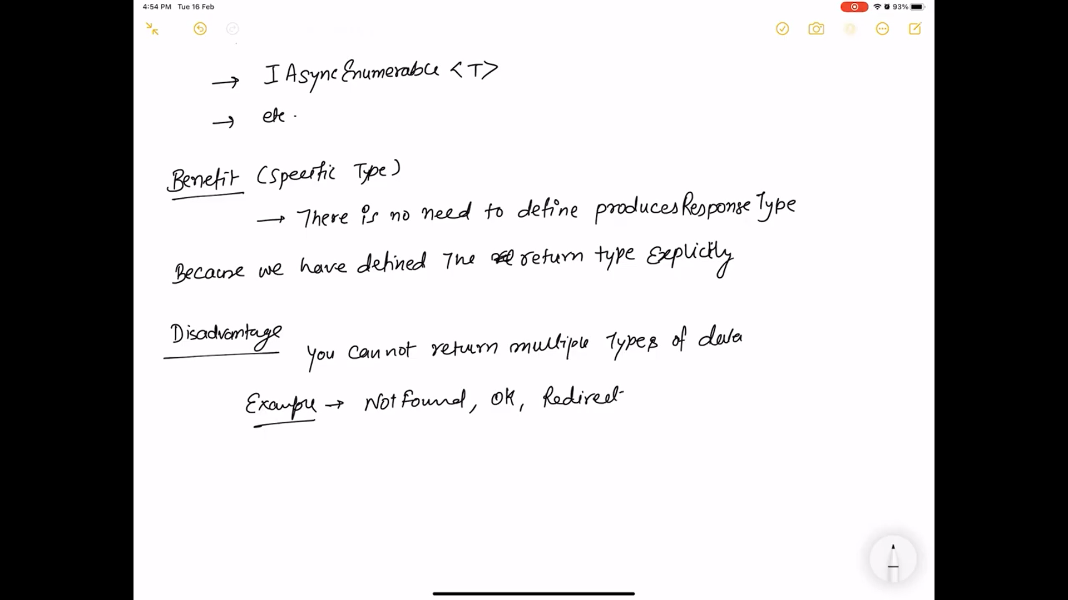

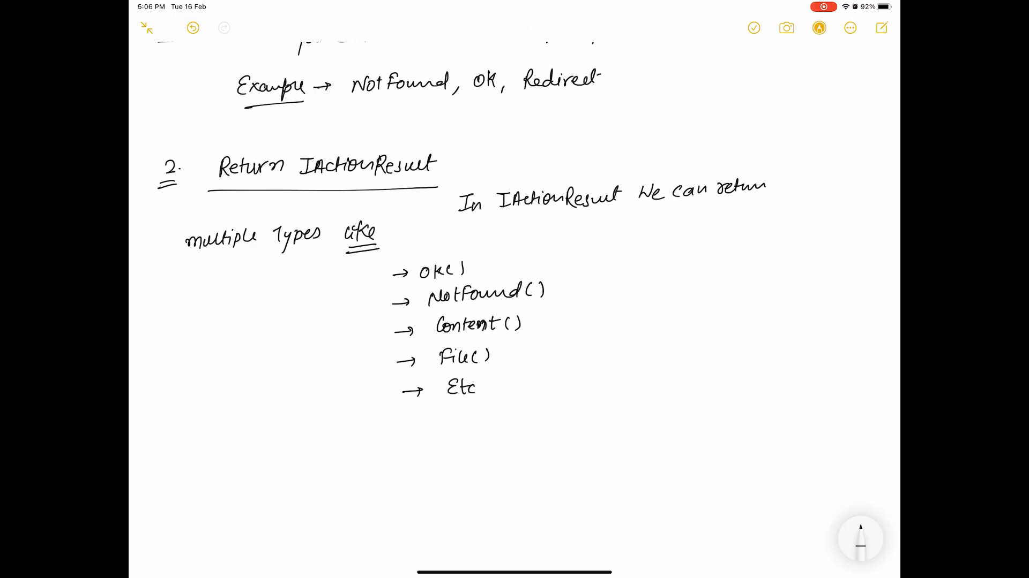

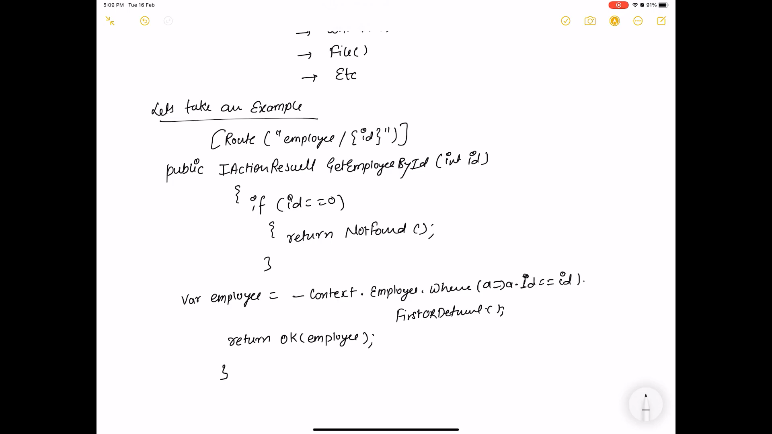

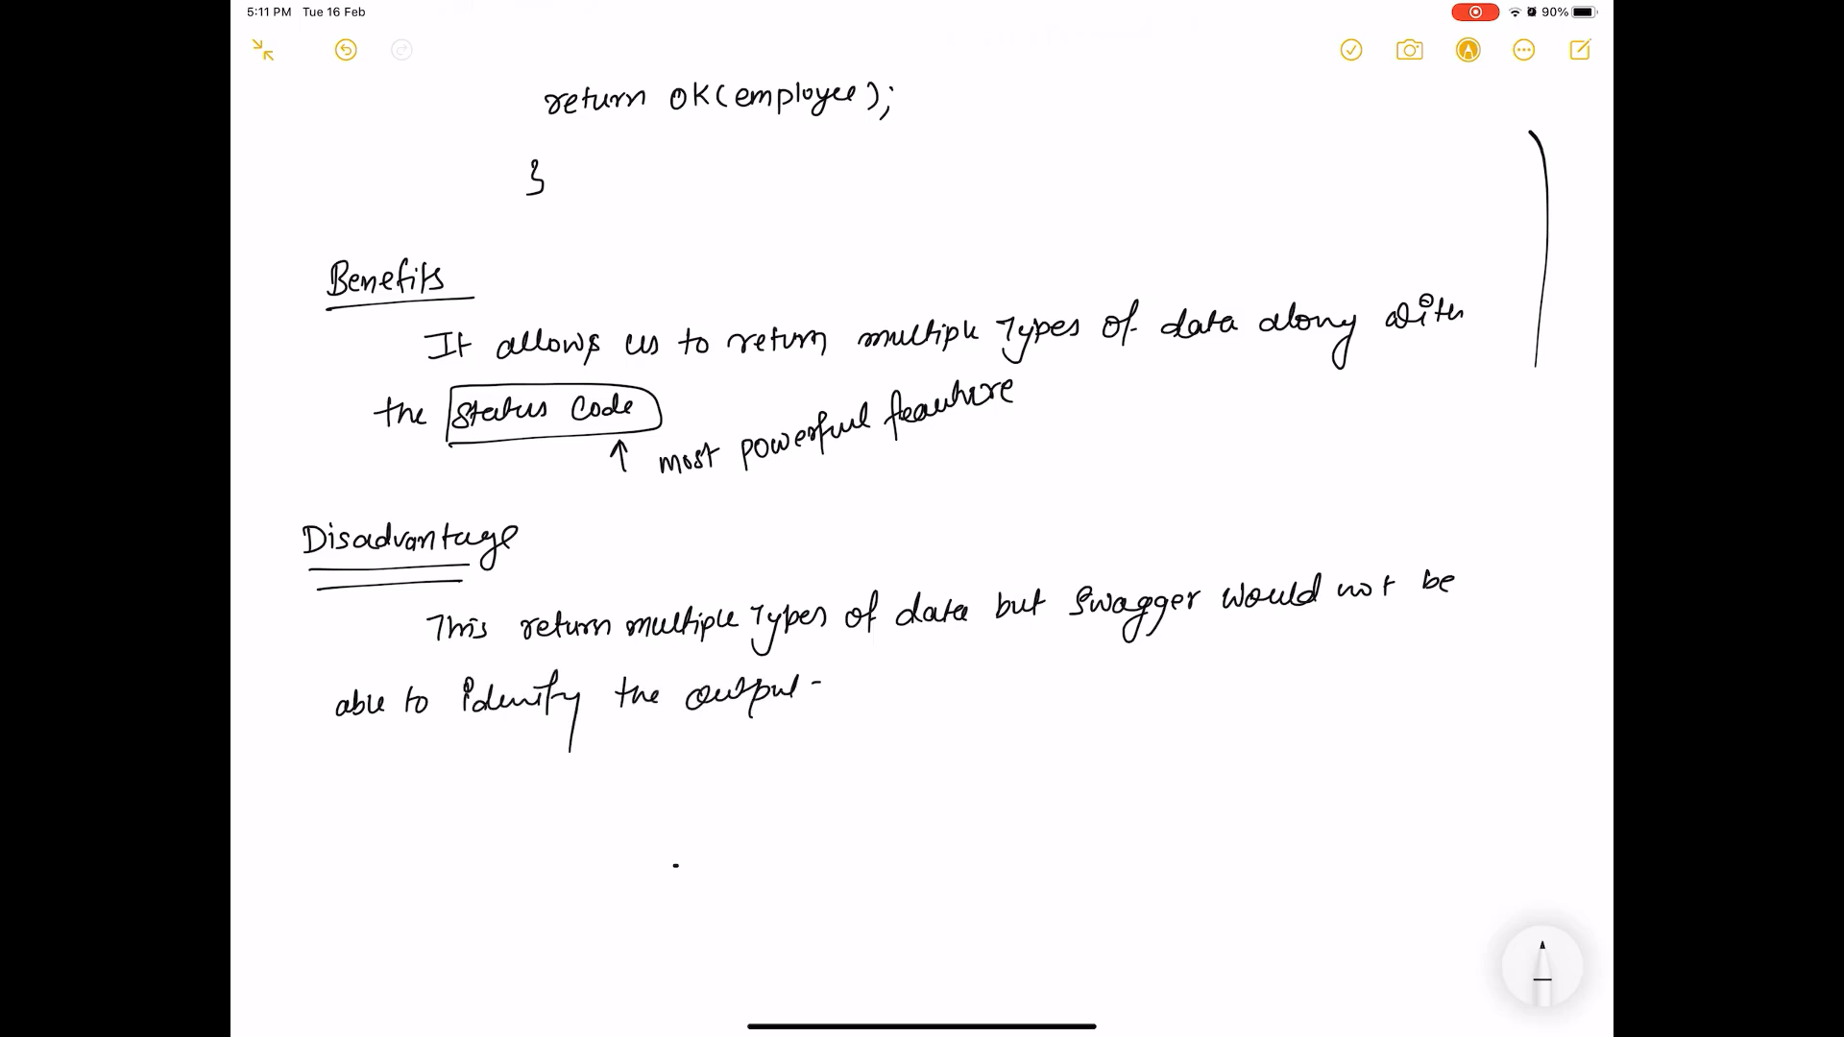

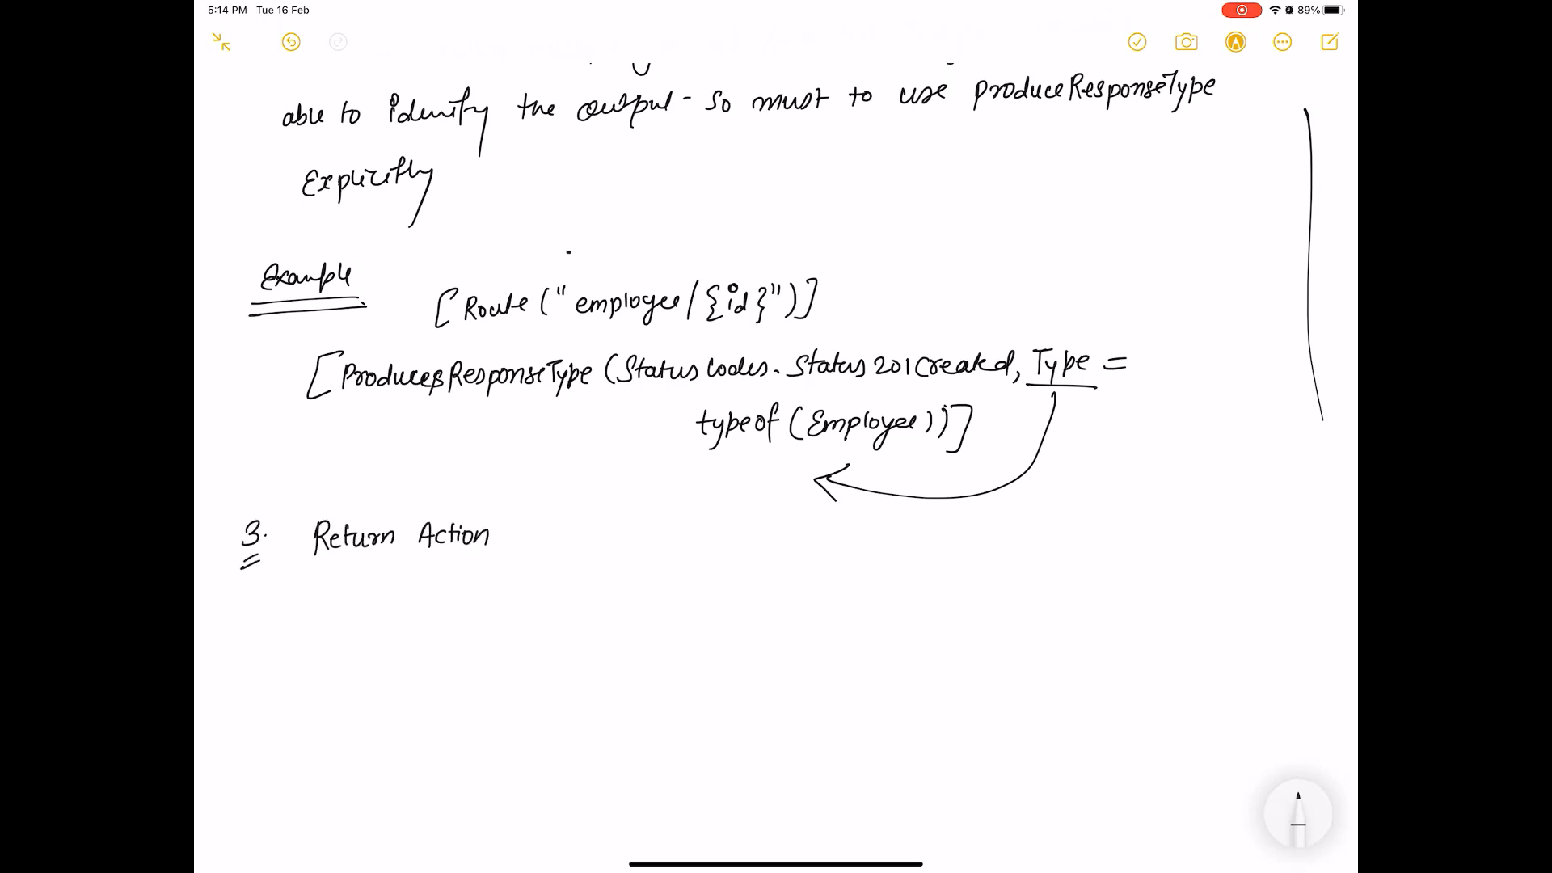

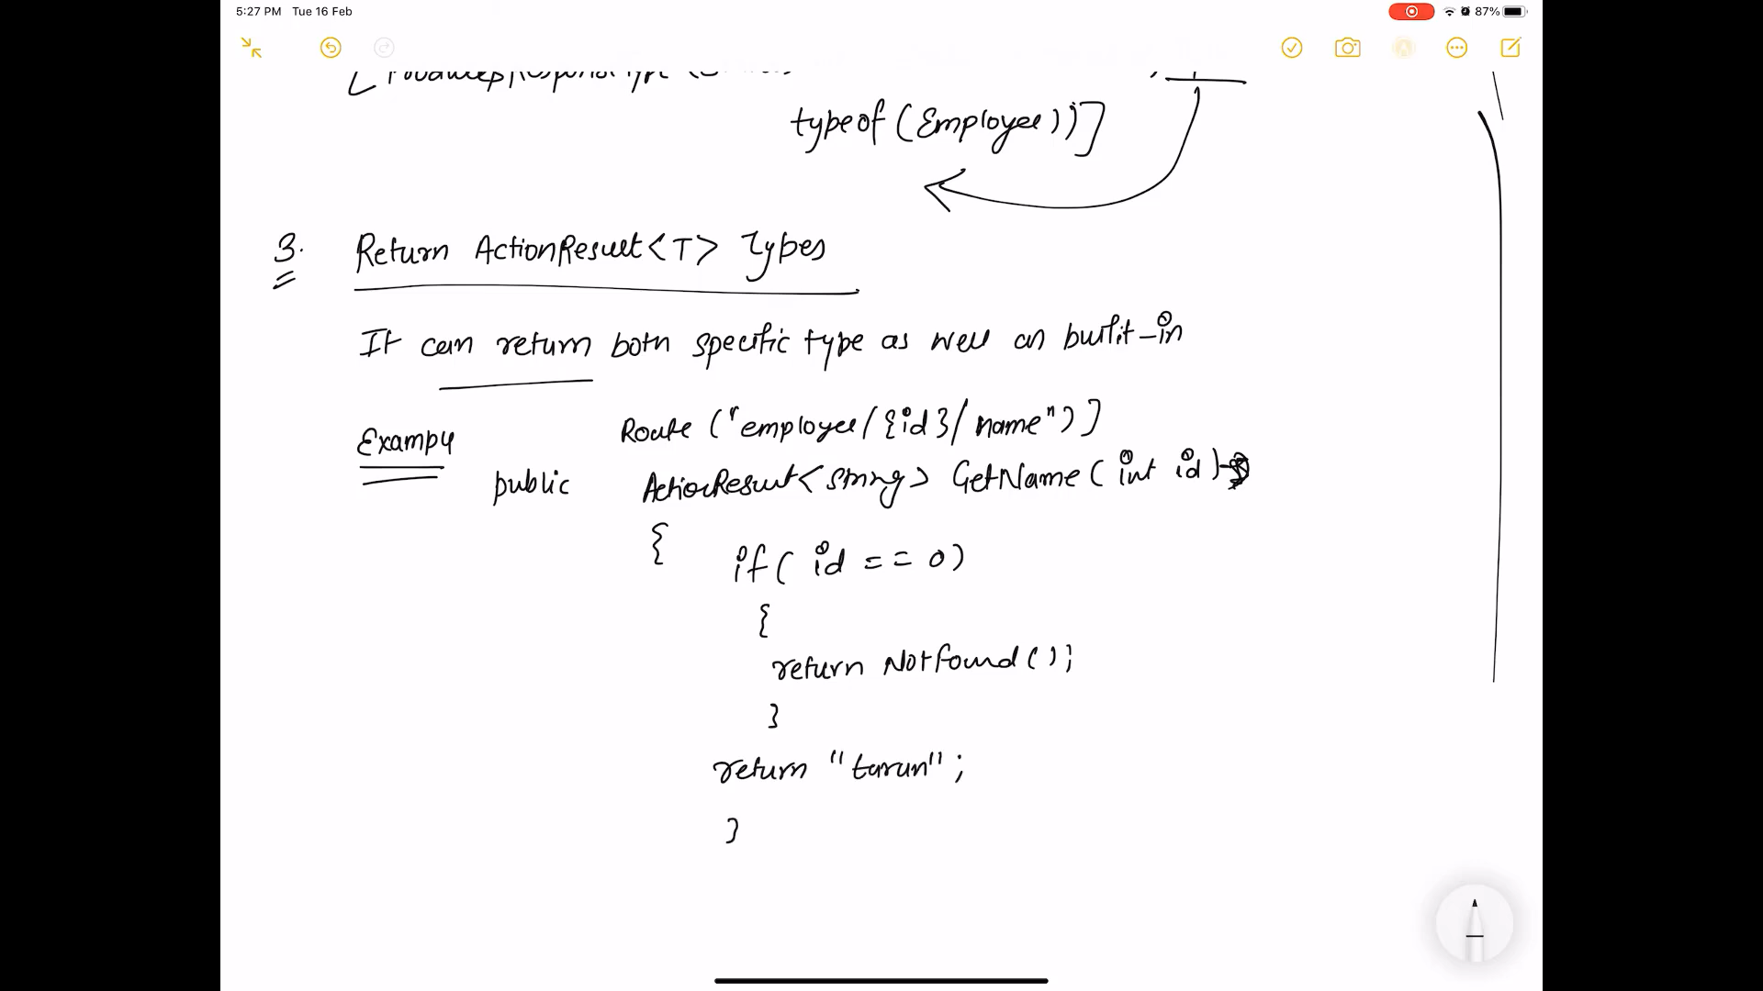

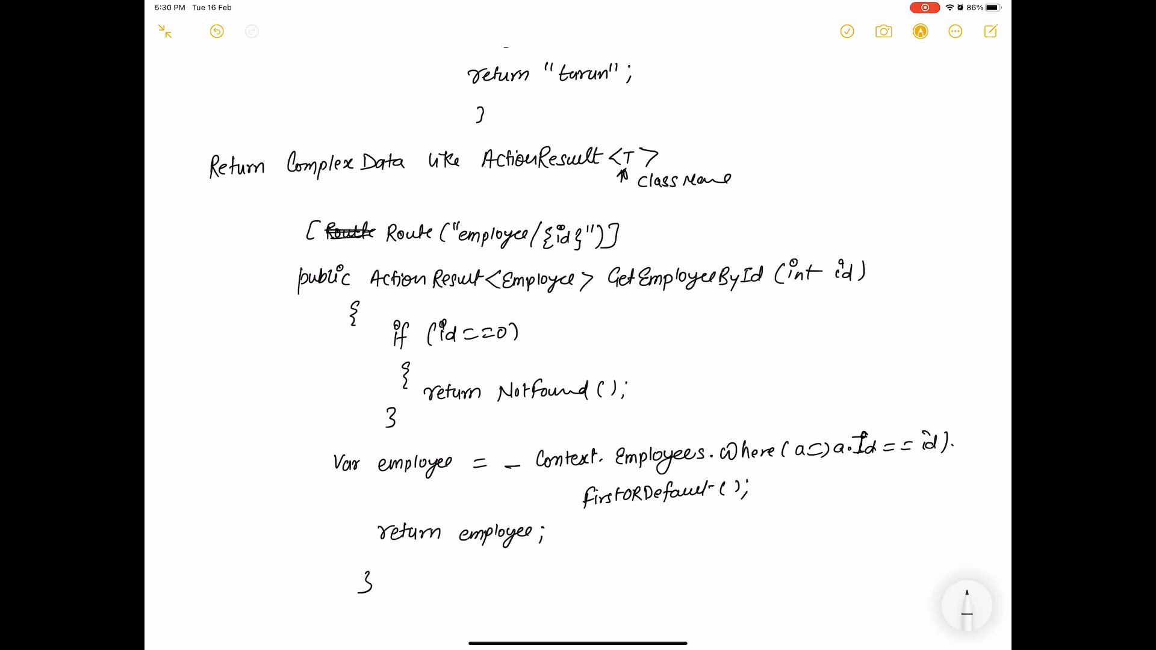

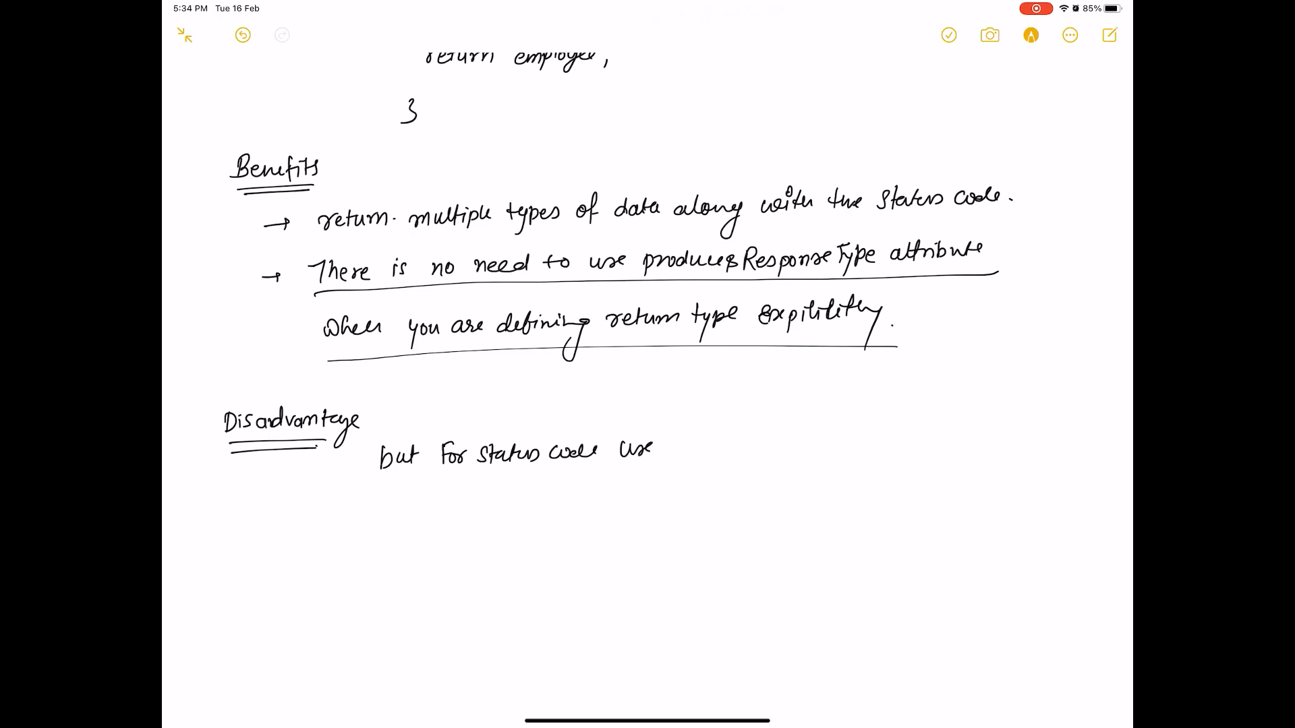

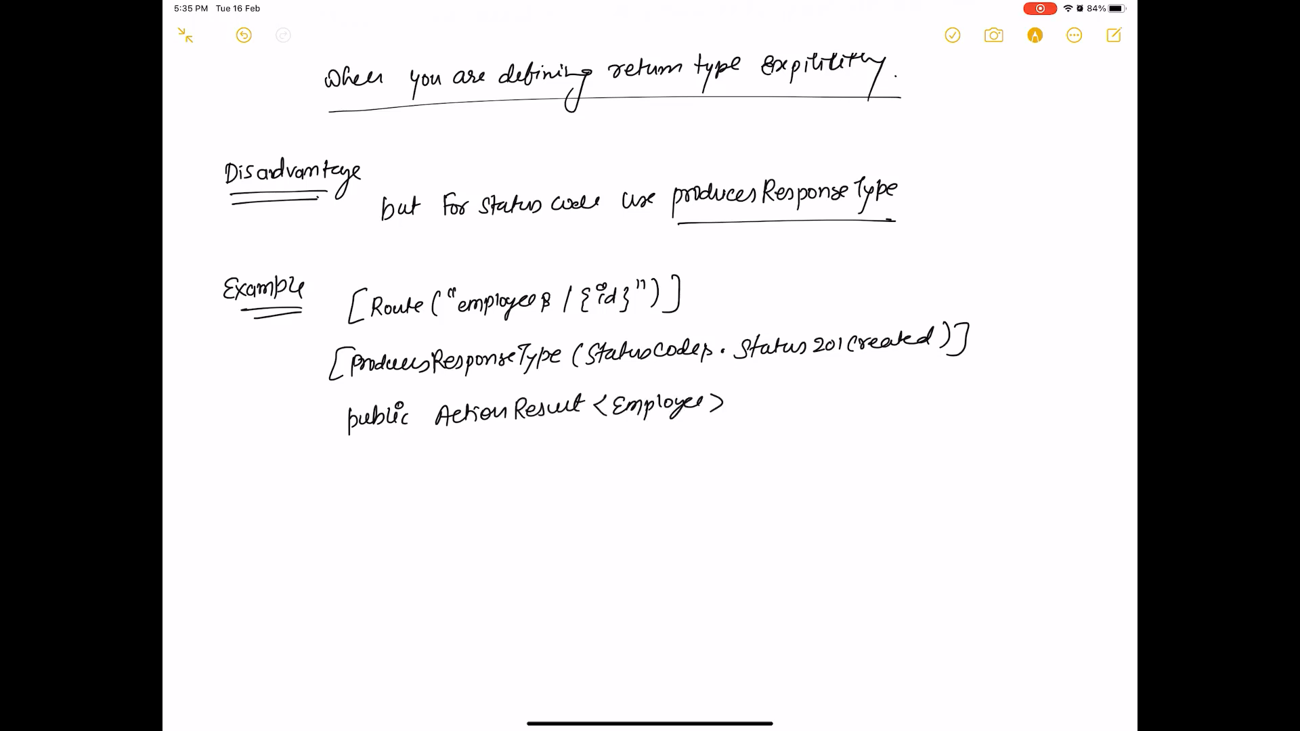

[HttpGet]

[Route("{id:int}")]

public IActionResult GetById(int id)

{

var obj = Students.FirstOrDefault(x => x.Id == id);

return Ok();

}

[HttpGet]

[Route("{id:int}")]

public IActionResult GetById(int id)

{

var obj = Students.FirstOrDefault(x => x.Id == id);

if (obj != null)

return Ok();

else

return NotFound();

}

[HttpGet]

[Route("{id:int}")]

public IActionResult GetById(int id)

{

var obj = Students.FirstOrDefault(x => x.Id == id);

if (obj != null)

return Ok(obj);

else

return NotFound();

}

[HttpPost]

public IActionResult Create(Student student)

{

Students.Add(student);

return Created("Created", student);

}

[HttpPost]

[ProducesResponseType(StatusCodes.Status201Created, Type=typeof(Student))]

[ProducesResponseType(StatusCodes.Status500InternalServerError, Type = typeof(string))]

public IActionResult Create(Student student)

{

Students.Add(student);

return Created("Created", student);

}

-------------------------------------------------

[HttpPost]

[ProducesResponseType(StatusCodes.Status201Created, Type=typeof(Student))]

[ProducesResponseType(StatusCodes.Status500InternalServerError, Type = typeof(string))]

public IActionResult Create(Student student)

{

try

{

Students.Add(student);

return Created("Created", student);

}

catch (Exception e)

{

return StatusCode(500, "Internal Server Error. Something went Wrong!");

}

}

ActionResult<>

[HttpGet]

[Route("{id:int}")]

public ActionResult<Student> GetById(int id)

{

var obj = Students.FirstOrDefault(x => x.Id == id);

if (obj != null)

return obj;

else

return NotFound();

}